SIMATS ENGINEERING (SAVEETHA SCHOOL OF ENGINEERING)
Department of Computer Science and Engineering
CO4 ASSESSMENT TOOL 2 - CI/CD PIPELINE DESIGN EXERCISE
Title: Smart Parking Management Platform
Field | Details
Course Code | CSA10 / CSA1063
Course Title | Software Engineering
CO Assessed | CO4
Assessment | Assessment Tool 2 - CI/CD Pipeline Design Exercise
Weightage | 20%
Total Marks | 25
CO4 Statement | Implement robust testing, quality assurance, and DevOps practices, emphasizing security, reliability, and ethics.
Problem Statement | Smart Parking Management Platform
Student Name | M.Ravi kiran
Reg. No. | 192325086
Duration | 60 minutes

Code of Conduct
I M.Ravi kiran (Name / Reg. No.) certify that this submission is my original work and that I have adhered to the guidelines specified for this assessment. I understand that any violation of academic integrity rules will result in disciplinary action.
Signature of the Student: M.Ravi kiran

1. Project & CI/CD Requirement Analysis
The Smart Parking Management Platform is composed of several independently deployable microservices (User, Vehicle, Booking, Payment, Notification, Gate-Control and Admin) plus a mobile app and an admin web portal. It must operate 24x7 across multiple physical parking locations with live hardware (barriers, sensors, QR/RFID readers). This creates the following specific CI/CD needs:
- Multiple independent microservices (User, Vehicle, Booking, Payment, Notification, Gate-Control, Admin) need frequent, independent build and release cycles.
- The platform must run 24x7 for live parking sites, so releases require zero/near-zero downtime deployment.
- The Payment module handles sensitive financial data and must pass strict security and vulnerability scanning before every release.
- Physical hardware integration (boom barriers, sensors, QR/RFID readers) makes safe, staged rollout and fast rollback critical to avoid stranding vehicles.
- The 38 test cases and NFR targets (2-second slot refresh, 10,000 concurrent users, 99.5% uptime) designed earlier must be executed automatically on every change, not manually.
- Multiple environments (developer, staging/UAT, production across several parking locations) require consistent, repeatable, automated environment provisioning.
- Rapid feedback to developers on build, test and quality-gate failures is required to keep release cycles short and defect cost low.

2. CI/CD Pipeline Stage Overview
Stage | Purpose
Source Code Management | Developers work on feature branches; pull requests are reviewed and merged into develop/main; a webhook triggers the pipeline automatically.
Build | Each microservice and the mobile/admin front-end are compiled and packaged; a versioned Docker image is produced for every service.
Automated Testing | Unit, integration, API, UI/E2E, performance and security tests execute automatically, gating promotion to the next stage.
Code Quality Analysis | Static analysis measures maintainability, code smells, duplication and coverage against a defined quality gate.
Packaging | Docker images are tagged with the commit SHA/semantic version and pushed to a container registry.
Deployment | Images are deployed to Dev, then Staging, then Production using Kubernetes, with Blue-Green/Canary strategy in production.
Monitoring & Rollback | Live health, error-rate and performance metrics are watched post-deployment; a failing release is rolled back automatically.

3. Pipeline Architecture Diagram
The diagram below shows the complete workflow from a developer's code commit through build, test, quality and security gates, packaging, staged deployment, production release and post-deployment monitoring with automatic rollback.
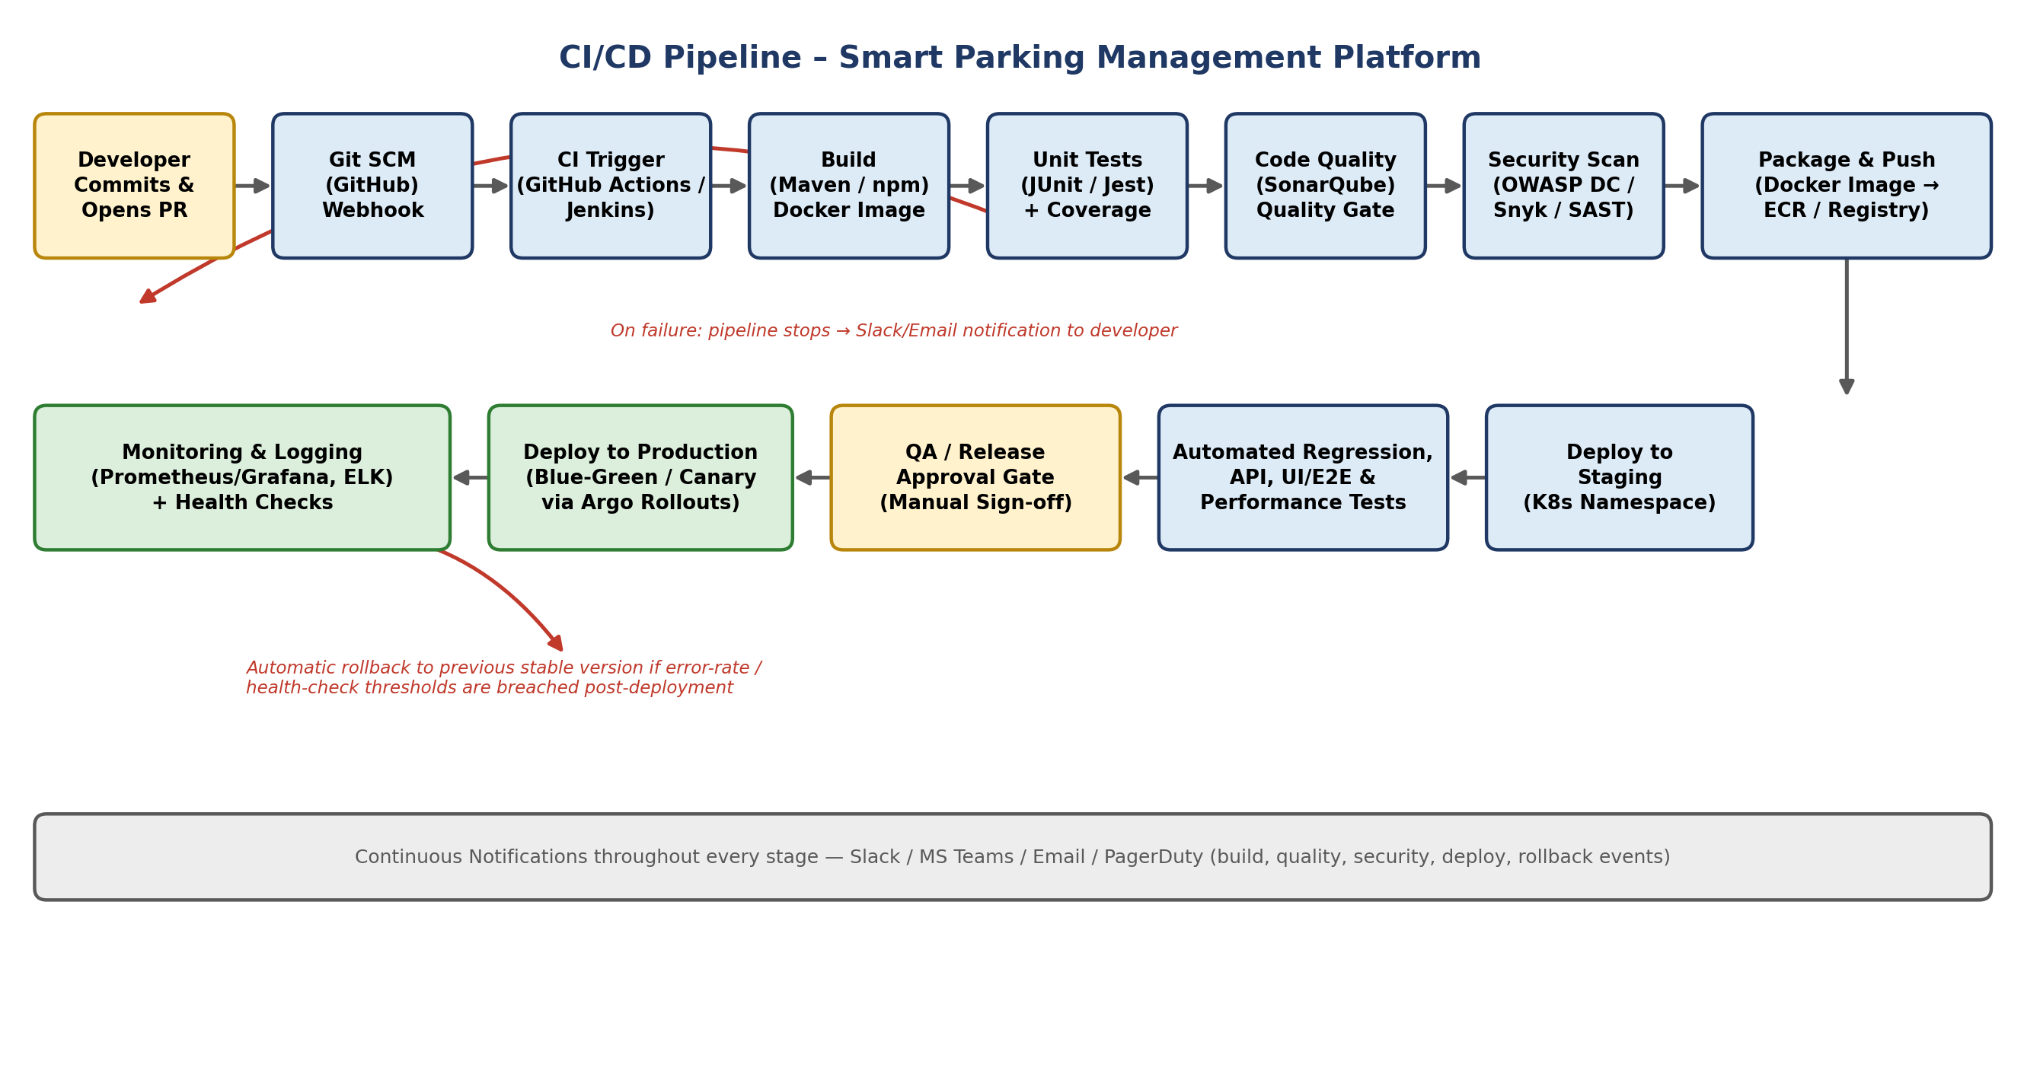

4. Tools & Technology Selection
Each pipeline stage uses a tool chosen to fit the platform's technology stack, scale and security requirements, as justified below.
Pipeline Stage | Tool(s) | Justification
Source Code Management | GitHub (Git) | Industry-standard distributed VCS; supports branch protection, pull-request review and native webhook triggers for CI.
CI/CD Orchestration | GitHub Actions / Jenkins | Pipeline-as-code (YAML/Jenkinsfile), version-controlled alongside the application, large plugin/action ecosystem.
Build Tool | Maven (backend Java/Spring Boot), npm/Yarn (React/React Native) | Standard, well-supported build tools matching the platform's technology stack for each service type.
Unit Testing | JUnit 5 + Mockito (backend), Jest + React Testing Library (frontend) | De-facto testing frameworks for the respective stacks; integrate natively with CI reporting.
Code Coverage | JaCoCo (backend), Istanbul (frontend) | Measures test coverage and enforces the minimum-coverage quality gate before merge.
Static Code Analysis | SonarQube | Detects bugs, code smells and vulnerabilities; enforces a configurable Quality Gate that blocks a bad build.
Security / Dependency Scanning | OWASP Dependency-Check / Snyk | Flags known CVEs in third-party libraries; mandatory for the Payment and Auth services.
Containerization | Docker | Provides a consistent runtime across Dev/Staging/Production and simplifies independent microservice deployment.
Container Registry | AWS ECR / Docker Hub | Secure, versioned storage and distribution of built images to every environment.
API / Integration Testing | Postman + Newman, REST-assured | Automates contract and endpoint verification between Booking, Payment and Notification services.
Container Orchestration | Kubernetes (EKS/GKE) + Helm | Automates scaling, self-healing and rolling/blue-green/canary deployment of containerized services.
Progressive Delivery | Argo Rollouts | Automates canary/blue-green rollout with metric-based analysis and automatic rollback on failure.
UI / End-to-End Testing | Selenium (admin web portal), Appium (mobile app) | Automates the 38 designed functional test cases end-to-end across booking, payment and gate-control flows.
Performance / Load Testing | Apache JMeter / k6 | Validates the 2-second refresh (NFR01) and 10,000-concurrent-user (NFR02) targets before go-live.
Security (DAST) | OWASP ZAP | Runs dynamic scans against the staging environment to catch runtime vulnerabilities before production release.
Monitoring & Alerting | Prometheus + Grafana | Real-time metrics on slot sensors, gate hardware and payment gateway health, feeding rollback decisions.
Centralized Logging | ELK / EFK Stack | Aggregated, searchable logs across all microservices for fast root-cause analysis.
Secrets Management | HashiCorp Vault / AWS Secrets Manager | Keeps API keys, DB credentials and payment gateway secrets out of source code and CI logs.
Infrastructure as Code | Terraform | Reproducible, version-controlled provisioning of identical Dev/Staging/Production infrastructure.
Notifications | Slack / MS Teams Webhooks, Email, PagerDuty | Keeps the team informed in real time of build, quality, security, deployment and rollback events.

5. Automated Testing Strategy
Testing is layered through the pipeline so that cheaper, faster checks run first and gate progression to more expensive checks, in line with the test-case design produced for this system (TC01-TC38).
Test Level | Tool(s) | When It Runs | Purpose
Unit Testing | JUnit 5 / Jest | On every commit / PR | Validate individual functions and components in isolation; fastest feedback loop.
Static & Security Analysis | SonarQube, OWASP Dependency-Check | On every commit / PR | Catch code smells, bugs and known vulnerable dependencies before they reach the build artifact.
Integration & API Testing | REST-assured, Postman/Newman | After successful build | Verify Booking, Payment and Notification services interact correctly across real API contracts.
Contract Testing | Pact | After successful build | Ensure a change in one microservice does not silently break a consumer service's expectations.
Functional / Regression (E2E) Testing | Selenium, Appium | On deployment to Staging | Automate the 38 test cases from the Test Case Design (TC01-TC38) covering registration, booking, entry/exit, payment and admin flows.
Performance / Load Testing | Apache JMeter / k6 | On Staging, before Production promotion | Confirm the system meets NFR01 (2-second refresh) and NFR02 (10,000 concurrent users).
Security / Penetration Testing (DAST) | OWASP ZAP | Scheduled + before major Production release | Validate NFR04 encryption and identify runtime vulnerabilities in a running environment.
Smoke Testing | Lightweight automated health checks | Immediately after every deployment (Staging & Production) | Confirm critical paths - login, booking, payment, gate control - are functioning before releasing traffic.

6. Deployment Strategy
Environment | Deployment Approach | Purpose
Development | Auto-deployed on every merge to the develop branch; ephemeral per-feature-branch namespaces | Early integration feedback for developers; not customer-facing
Staging / UAT | Auto-deployed after CI passes on the release branch; mirrors production configuration and data shape | Full regression, performance and security testing plus stakeholder/QA sign-off before go-live
Production | Blue-Green deployment for major releases (payment logic, gate control); Canary rollout (5% -> 25% -> 100% traffic) for minor features/fixes, promoted automatically only if health metrics stay within threshold | Serves live traffic across all parking locations with zero/near-zero downtime

Blue-Green deployment is used for high-risk changes (payment logic, gate-control firmware/API) since it keeps a complete, instantly-switchable standby environment. Canary releases are used for lower-risk feature and bug-fix changes, progressively shifting 5% -> 25% -> 100% of live traffic while Argo Rollouts automatically monitors error rate and latency at each step.

7. Security, Quality Gates, Notifications & Rollback
Control | Description
Branch Protection & Review | Pull requests require at least one reviewer approval and a passing CI run before merge to main/develop.
Quality Gate | SonarQube blocks promotion on any blocker/critical issue or if coverage falls below 80%.
Dependency & Vulnerability Scanning | OWASP Dependency-Check/Snyk runs on every build; OWASP ZAP DAST scan runs on staging before production.
Secrets Management | No credentials in source code; all secrets are injected at runtime from HashiCorp Vault / AWS Secrets Manager.
Encryption in Transit & at Rest | TLS enforced end-to-end and mTLS between microservices, satisfying NFR04; database encryption at rest.
Role-Based Access Control (RBAC) | Pipeline and Kubernetes-namespace access is restricted by role, preventing unauthorized deployments.
Audit Logging | Every build, approval and deployment event is immutably logged for compliance and traceability.
Automated Rollback | Argo Rollouts continuously analyzes error-rate and latency metrics after each deployment step; if a threshold is breached, traffic is automatically shifted back to the last stable version.
Database Migration Safety | Schema changes use versioned, reversible migration scripts (Flyway/Liquibase) so a rollback restores compatibility with the previous release.
Notifications | Slack/MS Teams/Email notify the team on build, quality-gate, security-scan, deployment and rollback events; PagerDuty pages the on-call engineer on failed post-deploy health checks.

8. End-to-End Workflow Explanation (Commit to Deployment)
Step | Stage | Description
1 | Commit & Pull Request | A developer pushes code to a feature branch and opens a pull request; peer review and branch-protection rules apply.
2 | CI Trigger | Merging to develop/main fires a GitHub Actions/Jenkins webhook that starts the pipeline automatically.
3 | Build | The affected microservice(s) and/or front-end are compiled with Maven/npm and packaged into a Docker image.
4 | Unit Testing | JUnit/Jest test suites run with coverage measured by JaCoCo/Istanbul; the build fails fast if any test fails.
5 | Code Quality Analysis | SonarQube performs static analysis; the pipeline halts if the Quality Gate (coverage, bugs, code smells) is not met.
6 | Security Scanning | OWASP Dependency-Check/Snyk scans dependencies for known CVEs, with extra scrutiny on the Payment and Auth services.
7 | Packaging | A versioned Docker image (tagged with commit SHA/semver) is pushed to the container registry (ECR/Docker Hub).
8 | Deploy to Staging | Helm deploys the new image to the Staging Kubernetes namespace, which mirrors production configuration.
9 | Automated Regression, API, UI/E2E & Performance Testing | The 38 designed test cases run via Selenium/Appium/Postman, followed by JMeter/k6 load tests and an OWASP ZAP scan.
10 | QA / Release Approval Gate | For major releases, a manual sign-off is required from QA/release management before promotion to production.
11 | Deploy to Production | Argo Rollouts performs a Blue-Green (major release) or Canary (minor release) deployment, gradually shifting live traffic.
12 | Monitoring & Health Checks | Prometheus/Grafana and the ELK stack continuously monitor error rate, latency and hardware/sensor health.
13 | Automatic Rollback (if needed) | If health-check or error-rate thresholds are breached, Argo Rollouts automatically reverts traffic to the last stable version.
14 | Notification | Slack/MS Teams/Email/PagerDuty notify the team at every stage transition, success or failure, throughout the pipeline.

9. Conclusion
This CI/CD pipeline automates the Smart Parking Management Platform's journey from code commit to production release: every change is built, unit-tested, statically analyzed, security-scanned, packaged, and progressively deployed through Development, Staging and Production with automated regression, performance and security testing at each gate. Blue-Green/Canary deployment combined with continuous monitoring and automatic, metric-driven rollback ensures the platform's 24x7 reliability (NFR03), security of payment data (NFR04) and scalability targets (NFR01, NFR02) are protected on every release, while Slack/Email/PagerDuty notifications keep the team informed throughout.

